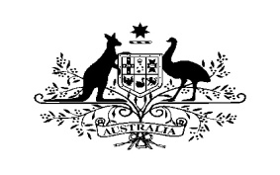

AUSTRALIAN EMBASSY – DIRECT AID PROGRAM

For projects in Turkey, Georgia and Azerbaijan

APPLICATION FORM

Project Year:
Project Number (if more than one):

Information about program applicant

Name of applicant/organisation:
Contact details of organisation:

Address:

Phone no:
Fax no:
Website (if applicable):

Brief description of organisation:
Date of establishment:
Name of project coordinator:

Contact details:
Phone no (office):
Phone no (mobile):
Fax no:
E-mail:

A short description of previous projects (if applicable):

Project details

Name of project:

Brief description of project:

Reason for project (objectives):

Target group for project:

Duration of project:

Location of project : (city, town, village)

Name of the institutions/organisations with whom you plan to cooperate:

Please explain how the sustainability of the project will be ensured

Total cost of project in AUD:

Amount sought from the Australian Embassy in AUD:

Contribution of the project applicant:
(in kind or cash)

Thank you for your application.
Contact details:
Elif Barutcuoğlu Wade
elif.barutcuoglu-wade@dfat.gov.au
Phone : 0312-459 9504
Fax: 0312-459 9503

